**Unit 4 QB: -**

1. Give the definition of provisioning. Explain the benefits, long-term and short-time goals of provisioning in cloud management.

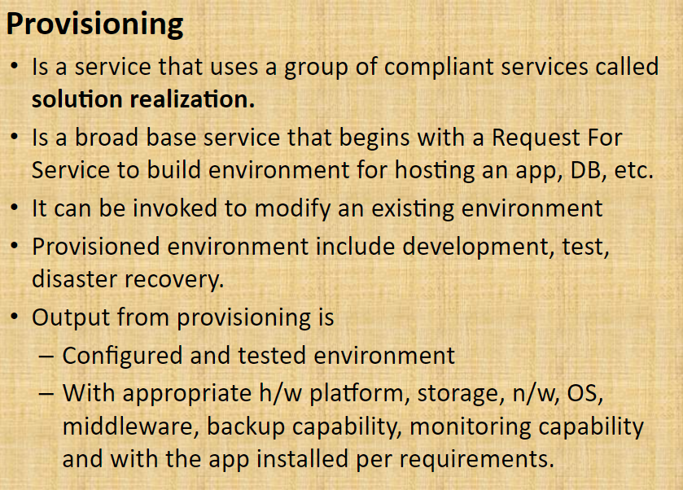

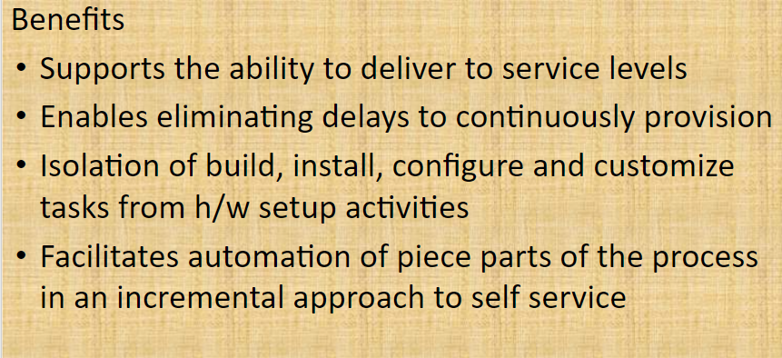

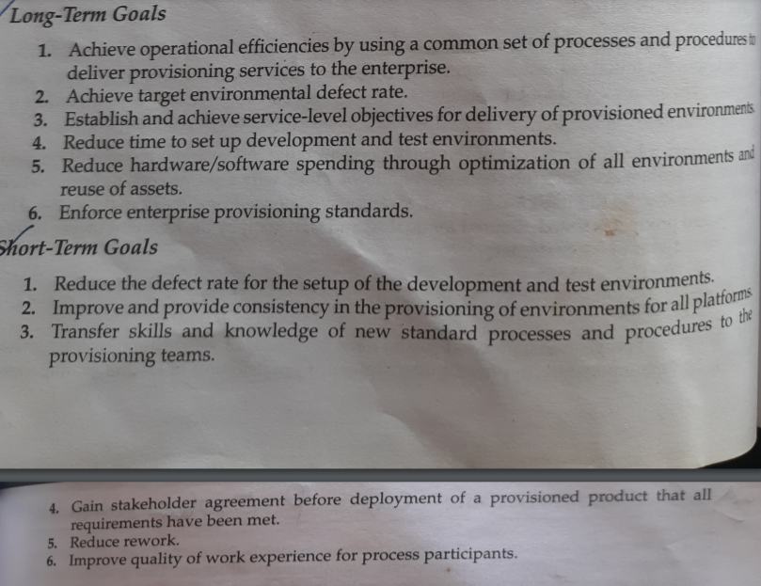

1. List & explain the different factors that help to develop asset management strategy.

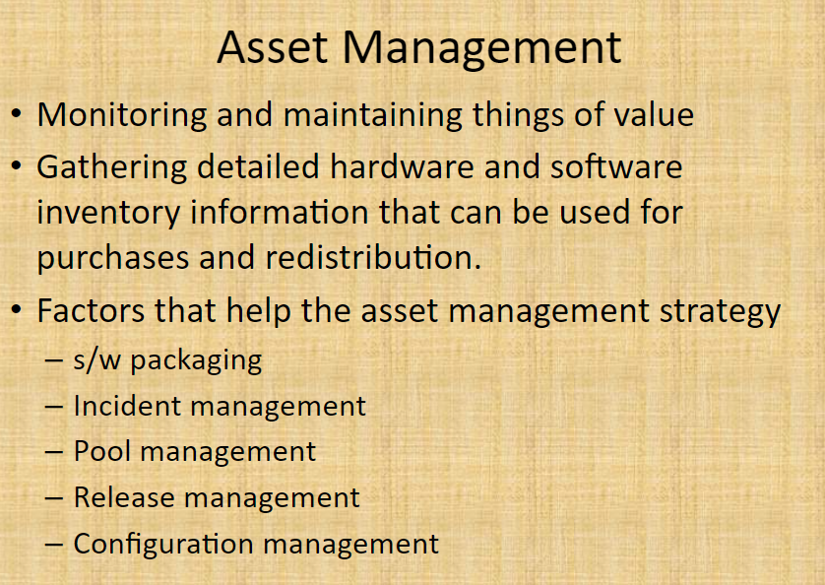

1. Define Resiliency and its capabilities.

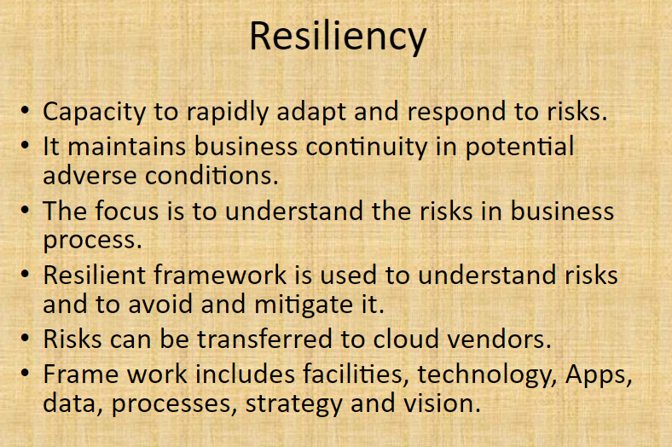

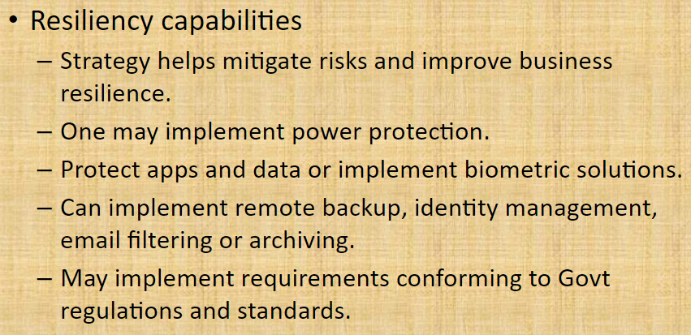

1. Explain cloud governance model with a block diagram.

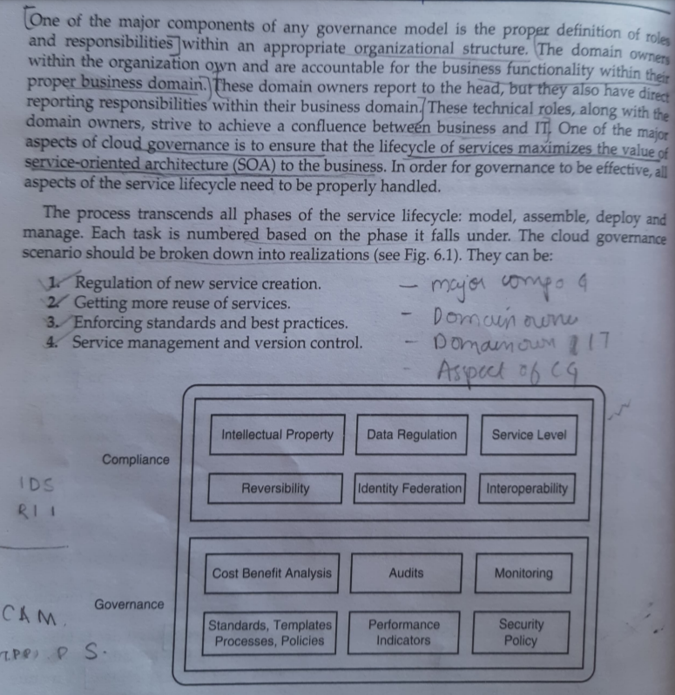

1. Explain the following i) Mean Time Between Failure ii) Mean Time to Recover iii) High Availability iv) Continuous Operations v) Continuous Availability

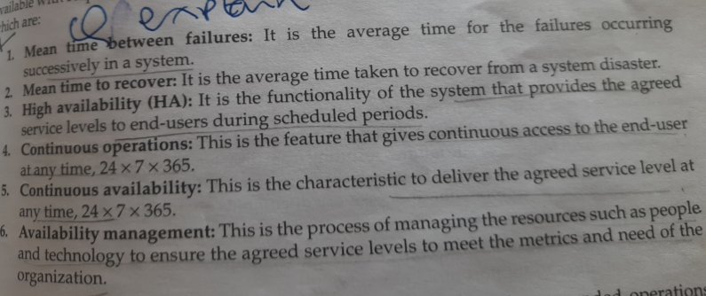

1. With a neat diagram explain any 3 Chargeback Model.

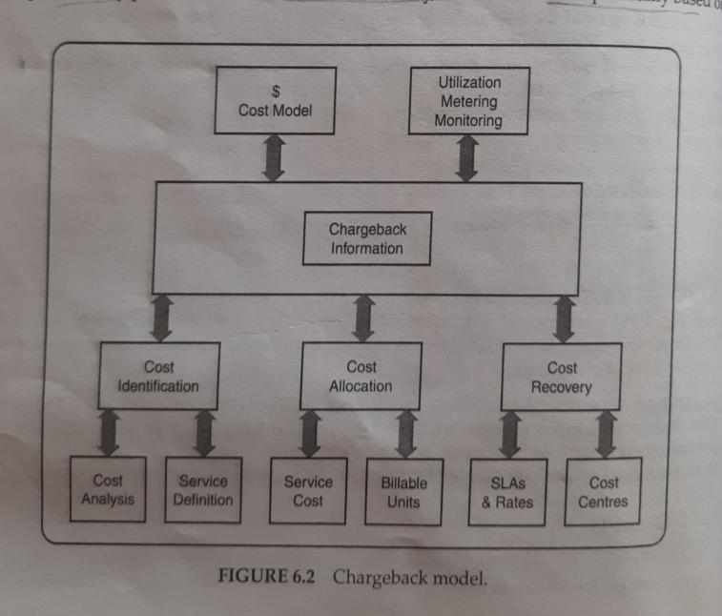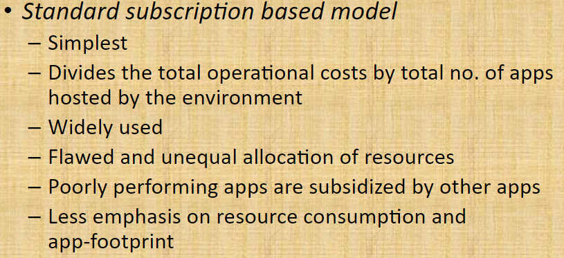

*Line of business (LOB)*:apps that are critical to enterprise functioning

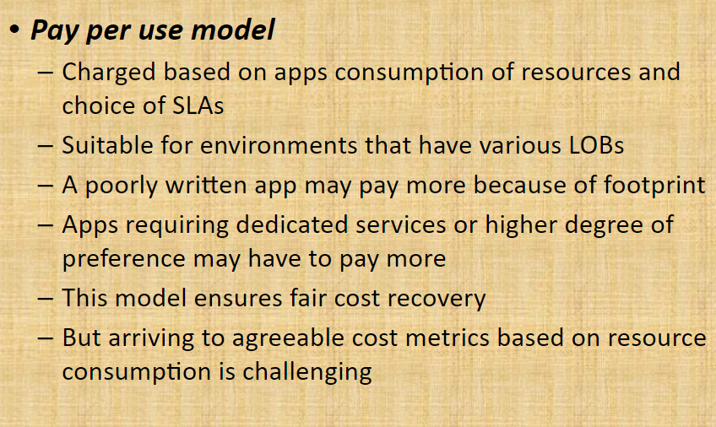

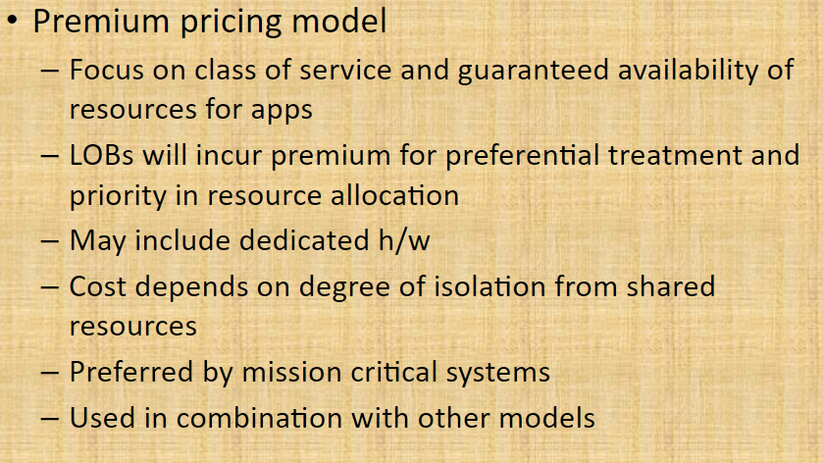

* Hybrid model – you know the answer bois